PSet 2 – CS 7649

CS 4649/7649 Robot Intelligence: Planning

Instructor: Matthew Gombolay

# Instructions:

* You may work with one or more classmates on this assignment. However, all work must be your own, original work (i.e., no copy+pasting code). You must list all people you worked with and sources you used on the document you submit for your homework
* All final solutions to written problem must be enclosed by a box to make it easy and unambiguous for the graders what your final answer is. If your answer is illegible, you will not receive credit. If you answer is not boxed, you will not receive credit.

# Problem 1:

Consider the following directed graph:

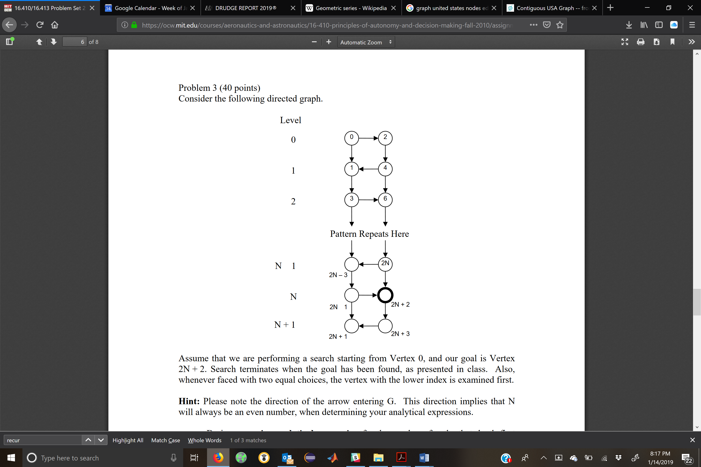

-

-

The start node is S = 0, and the goal node is G = 2N+2. Assume N > 0. Assume a visited list is used. Derive a precise analytical expression for the number of paths that DFS examines. During search, ties are broken by choosing the lower-index node (i.e., lower-index nodes are placed into the queue *after* higher-index nodes).

# Problem 2

Work out the A* execution trace for the graph below. You do not need to sort the queue when filling in the tables. Draw an arrow next to the partial path that you pop from the queue. Steps 0-1 have been completed for you below.

Step 0)

|  |  |  |  |
| --- | --- | --- | --- |
| **State** | **g** | **h** | **f** |
| <S> | 0 | 10 | 10 |

Step 1)

|  |  |  |  |
| --- | --- | --- | --- |
| **State** | **g** | **h** | **f** |
| <A,S> | 7 | 4 | 11 |
| <B,S> | 6 | 6 | 12 |

Step 2)

|  |  |  |  |
| --- | --- | --- | --- |
| **State** | **g** | **h** | **f** |
|  |  |  |  |
|  |  |  |  |
|  |  |  |  |

Step 3)

…(and so forth)…

# Problem 3

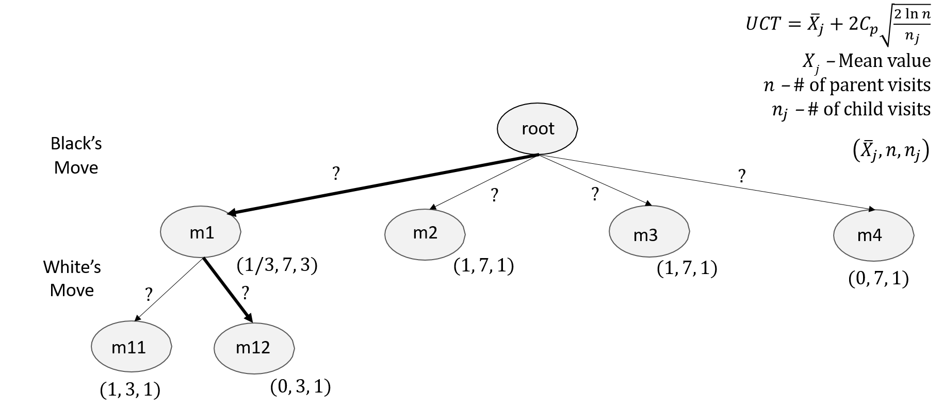After 7 rounds of MCTS for Othello, we arrive at the result shown below.

Fill in the missing edge (i.e., UCT) values for the following edges:

$w_{root,m1}=$

$w_{m1,m11}=$